DOCTOR’S BOOKING FORM
(WEST RAND CPD SYMPOSIUM 27 & 28 NOVEMBER 2021)
NAME
(Tittle, Initial, Surname)
DISCIPLINE
HPCSA NUMBER
SAMA NUMBER
CELL NUMBER
WORK TELEPHONE
EMAIL ADDRESS (Clear print please)
DIETARY  (Tick a box with X) | NORMAL | HALAAL | VEGETARIAN

Banking details:
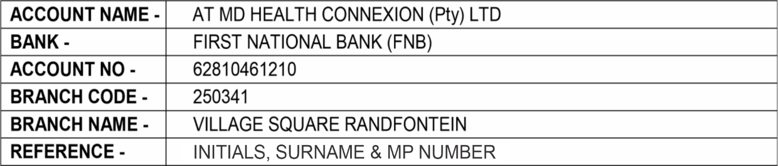

*COVID-19 PROTOCOLS*
MD HEALTH CONNEXIONS IS COMPLIANT TO COVID-19 HEALTH AND SAFETY PROTOCOLS.

Enquiries:
Maxwell Dali Ndlovu Ben Thabo
Tel: 011 951 0249 Cell: 079 524 2430 Cell: 067 810 6703 / Whatsapp
Email: maxwelln@mdhealthconnexions.co.za Email: bent@mdhealthconnexions.co.za

