Supplement Table 1. Crude and adjusted quantile regression for the outcome of 24-month retention
 | Crude quantile difference (95% CI) |  |  | Adjusted quantile difference (95% CI)
 | 25% | 50% | 75% | 25% | 50% | 75%
post PEPFAR | -5.3% (-10.3, -0.2%) | -5.8% (-9.7, -2.0%) | -3.5% (-7.7, 0.6%) | -5.8% (-11.5, -0.2%) | -6.9% (-10.2, -3.7%) | -1.6% (-6.2, 3.1%)
slope during PEPFAR | -1.0% (-2.0, -0.0%) | -1.2% (-2.0, -0.4%) | -2.0% (-2.8, -1.2%) | -0.5% (-1.7, 0.6%) | -1.2% (-1.9, -0.6%) | -2.8% (-3.7, -1.9%)
change in slope post-PEPFAR | 0.8% (-3.1, 4.7%) | 0.5% (-2.5, 3.5%) | 0.4% (-2.8, 3.5%) | 0.5% (-3.9, 4.9%) | 0.9% (-1.6, 3.4%) | 0.7% (-3.0, 4.3%)
constant | 54.5% (50.9, 58.2%) | 60.4% (57.6, 63.2%) | 63.5% (60.5, 66.5%) | 47.9% (40.1, 55.7%) | 65.5% (61.1, 70.0%) | 67.8% (61.4, 74.3%)
PEPFAR NGO
Anova (constant) | - | - | - | ref. | ref. | ref.
Kheth'impilo | - | - | - | 10.0% (4.7, 15.2%) | 1.1% (-1.8, 4.1%) | 1.1% (-3.2, 5.5%)
Anova/ Kheth'impilo | - | - | - | 3.6% (-2.2, 9.4%) | -2.8% (-6.2, 0.5%) | -2.8% (-7.6, 2.0%)
Right to Care | - | - | - | 9.2% (1.7, 16.8%) | 8.1% (3.8, 12.4%) | 9.4% (3.1, 15.6%)
that'sit | - | - | - | 5.5% (-0.1, 11.0%) | 6.0% (2.8, 9.2%) | 7.6% (3.0, 12.2%)
clinic size
174-1020 (constant) | - | - | - | ref. | ref. | ref.
1021-2562 | - | - | - | 7.7% (2.1, 13.3%) | 2.5% (-0.7, 5.7%) | 3.2% (-1.5, 7.8%)
2563-4021 | - | - | - | 7.4% (1.7, 13.1%) | 1.5% (-1.8, 4.7%) | -0.9% (-5.7, 3.8%)
4022-5856 | - | - | - | 7.2% (1.4, 13.1%) | 0.9% (-2.5, 4.2%) | 0.8% (-4.1, 5.6%)
5857-9760 | - | - | - | 10.0% (3.1, 16.9%) | 0.8% (-3.1, 4.8%) | -2.8% (-8.6, 2.9%)
Location
urban (constant) | - | - | - | ref. | ref. | ref.
rural | - | - | - | 4.9% (-1.4, 11.2%) | -2.5% (-6.0, 1.1%) | -5.0% (-10.2, 0.3%)
government support
City of Cape Town (constant) | - | - | - | ref. | ref. | ref.
Western Cape Government | - | - | - | -7.2% (-12.0, -2.6%) | -7.9% (-10.6, -5.2%) | -8.2% (-12.1, -4.3%)
Combined | - | - | - | 2.5% (-6.3, 11.3%) | -5.0% (-10.0, 0.1%) | -6.5% (-13.8, 0.8%)
CI = confidence interval; PEPFAR = President's Emergency Plan for AIDS Relief

Supplemental Table 2. Basic quantile regression models for the outcome of 12- and 24-month retention
 | Basic quantile difference (95% CI) 12-month |  |  |  |  |  |  | Basic quantile difference (95% CI) 24-month
 | 25% | 25% |  | 25% |  | 25% |  | 25% | 25% | 25% |  | 25%
12 month retention
post PEPFAR | -6.9% (13.5, -0.2%) | -5.9% (-11.4, -0.4%) |  | -6.0% (-12.6, 0.5%) |  | -4.5% (-11.3, 2.4%) |  | -4.5% (-10.1, 1.1%) | -5.2% (-9.6, -0.7%) | -5.4% (-10.5, -0.4%) |  | -6.7% (-11.6, -1.8%)
slope during PEPFAR | 0.4% (-1.0, 1.7%) | 0.5% (-0.6, 1.6%) |  | 0.3% (-1.0, 1.6%) |  | 0.4% (-0.9, 1.8%) |  | -0.5% (-1.6, 0.6%) | -0.6% (-1.5, 0.3%) | -0.7% (-1.7, 0.3%) |  | -0.4% (-1.4, 0.5%)
change in slope post-PEPFAR | 0.6% (-4.6, 5.8%) | 0.1% (-4.1, 4.4%) |  | -0.4% (-5.5, 4.6%) |  | -0.9% (-6.2, 4.4%) |  | 0.1% (-4.3, 4.4%) | 0.2% (-3.3, 3.7%) | 0.1% (-3.8, 4.1%) |  | 0.5% (-3.3, 4.3%)
constant | 58.4% (53.0, 63.8%) | 56.7% (52.0, 61.3%) |  | 65.0% (60.0, 7.0%) |  | 71.1% (65.0, 77.3%) |  | 52.7% (48.2, 57.2%) | 51.6% (47.7, 55.4%) | 57.3% (53.4, 61.3%) |  | 63.4% (59.0, 67.8%)
PEPFAR NGO
Anova | ref. | - |  | - |  | - |  | ref. | - | - |  | -
Kheth'impilo | 8.7% (4.2, 13.3%) | - |  | - |  | - |  | 7.8% (4.0, 11.6%) | - | - |  | -
Anova/ Kheth'impilo | 5.3% (-0.5, 11.1%) | - |  | - |  | - |  | 2.1% (-2.8, 6.9%) | - | - |  | -
that'sit | 3.9% (-3.7, 11.5%) | - |  | - |  | - |  | 3.7% (-2.6, 10.1%) | - | - |  | -
Right to Care | -0.8% (-6.1, 4.6%) | - |  | - |  | - |  | 0.8% (-3.6, 5.3%) | - | - |  | -
Health Facility size
174-1020 | - | ref. |  | - |  | - |  | - | ref. | - |  | -
1021-2562 | - | 4.5% (-0.1, 9.1%) |  | - |  | - |  | - | 3.4% (-0.3, 7.2%) | - |  | -
2563-4021 | - | 1.6% (-3.1, 6.3%) |  | - |  | - |  | - | 1.8% (-2.0, 5.6%) | - |  | -
4022-5856 | - | 12.3% (7.6, 16.9%) |  | - |  | - |  | - | 8.6% (4.8, 12.4%) | - |  | -
5857-9760 | - | 6.0% (1.2, 10.7%) |  | - |  | - |  | - | 3.6% (-0.3, 7.4%) | - |  | -
Location
Urban | - | - |  | ref. |  | - |  | - | - | ref. |  | -
Rural | - | - |  | -6.0% (-9.5, -2.5%) |  | - |  | - | - | -3.7% (-6.4, -1.0%) |  | -
government support
City of Cape Town | - | - |  | - |  | ref. |  |  | - | - |  | ref.
Western Cape Gov | - | - |  | - |  | -1.5% (-11.8, 8.8%) |  |  | - | - |  | -8.5% (-11.8, -5.2%)
Combined | - | - |  | - |  | -11.3% (-15.9, 6.7%) |  |  | - | - |  | -2.8% (-10.2, 4.6%)
 | 50% | 50% |  | 50% |  | 50% |  | 50% | 50% | 50% |  | 50%
12 month retention
post PEPFAR | -4.5% (-9.4, 0.4%) | -5.4% (-9.8, -1.0%) |  | -5.1% (-9.7, -0.6%) |  | -5.3% (-9.1, -1.4%) |  | -5.0% (-8.4, -1.7%) | -5.6% (-9.3, -1.9%) | -5.5% (-9.3, -1.7%) |  | -5.8% (-9.3, 2.3%)
slope during PEPFAR | -1.4% (-2.3, -0.4%) | -0.8% (-1.7, 0.1%) |  | -1.0% (-1.9, -0.0%) |  | -1.1% (-1.9, -0.3%) |  | -1.7% (-2.3, -1.0%) | -1.1% (-1.9, -0.4%) | -1.2% (-1.9, -0.4%) |  | -1.3% (-2.0, -0.6%)
change in slope post-PEPFAR | 0.5% (-3.3, 4.3%) | 0.1% (0.0, 3.4%) |  | 0.2% (-3.3, 3.8%) |  | 0.2% (-3.3., 3.8%) |  | 1.1% (-1.5, 3.7%) | 0.8% (-2.1, 3.7%) | 0.1% (-2.8, 3.1%) |  | 0.3% (-2.4, 3.0%)
constant | 63.6% (59.7, 67.6%) | 63.7% (60.0, 67.4%) |  | 70.0% (66.0, 73.1%) |  | 74.8% (71.3, 78.3%) |  | 55.8% (53.1, 58.5%) | 59.2% (56.0, 62.3%) | 61.9% (59.0, 64.9%) |  | 66.0% (62.8, 69.2%)
PEPFAR NGO
Anova | ref. | - |  | - |  | - |  | ref. | - | - |  | -
Kheth'impilo | 5.9% (2.6, 9.2%) | - |  | - |  | - |  | 6.4% (4.1, 8.6%) | - | - |  | -
Anova/ Kheth'impilo | 0.8% (-3.4, 5.1%) | - |  | - |  | - |  | 2.7% (-0.3, 5.6%) | - | - |  | -
that'sit | 0.6% (-5.0, 6.2%) | - |  | - |  | - |  | 6.6% (2.8, 10.4%) | - | - |  | -
Right to Care | 1.8% (-2.1, 5.8%) | - |  | - |  | - |  | 3.8% (1.1, 6.4%) | - | - |  | -
clinic size
174-1020 | - | ref. |  | - |  | - |  | - | ref. | - |  | -
1021-2562 | - | 1.5% (-2.2, 5.2%) |  | - |  | - |  | - | -0.3% (-3.4, 2.8%) | - |  | -
2563-4021 | - | 1.2% (-2.5, 5.0%) |  | - |  | - |  | - | 0.5% (-2.7, 3.6%) | - |  | -
4022-5856 | - | 8.8% (5.1, 12.5%) |  | - |  | - |  | - | 4.4% (-1.3, 7.6%) | - |  | -
5857-9760 | - | 3.6% (-0.2, 7.4%) |  | - |  | - |  | - | 0.1% (-3.1, 3.3%) | - |  | -
Location
Urban | - | - |  | ref. |  | - |  | - | - | ref. |  | -
Rural | - | - |  | -5.5% (-8.0, -3.1%) |  | - |  | - | - | -3.3% (-5.3, -1.3%) |  | -
government support
City of Cape Town | - | - |  | - |  | ref. |  | - | - | - |  | ref.
Western Cape Gov | - | - |  | - |  | -3.7% (-9.5, 2.1%) |  | - | - | - |  | -7.6% (-9.9, -5.2%)
Combined | - | - |  | - |  | -10.1% (-12.7, -7.6%) |  | - | - | - |  | -5.2% (-10.5, 0.1%)
 | 75% | 75% |  | 75% |  | 75% |  | 75% | 75% | 75% |  | 75%
12 month retention
post PEPFAR | -5.2% (-8.7, -1.6%) | -4.5% (-8.3, -0.7%) |  | -5.3% (-9.1, -1.5%) |  | -6.4% (-10.5, -2.4%) |  | -5.2% (-9.4, -1.0%) | -4.5% (-8.9, 0.0%) | -5.2% (-9.2, -1.2%) |  | -5.0% (-8.5, -1.5%)
slope during PEPFAR | -1.8% (-2.6, -1.2%) | -1.6% (-2.4, -0.9%) |  | -1.5% (-2.3, -0.8%) |  | -1.5% (-2.3, -0.7%) |  | -2.3% (-3.2, -1.5%) | -2.1% (-3.0, -1.2%) | -2.0% (-2.8, -1.2%) |  | -2.1% (-2.8, -1.4%)
change in slope post-PEPFAR | -3.6% (-2.7, 2.9%) | 0.0% (-3.0, 3.0%) |  | -0.6% (-3.6, 2.3%) |  | 1.9% (-0.4, 4.2%) |  | 1.0% (-2.3, 4.3%) | 0.8% (-2.7, 4.3%) | 0.4% (-2.7, 3.5%) |  | 0.0% (-2.7, 2.7%)
constant | 69.5% (66.7, 72.4%) | 73.4% (70.1, 76.6%) |  | 74.9% (72.0, 77.9%) |  | 77.9% (74.2, 81.6%) |  | 60.4% (57.0, 63.8%) | 64.9% (61.1, 68.7%) | 65.6% (62.5, 68.7%) |  | 69.2% (66.1, 72.4%)
PEPFAR NGO
Anova | ref. | - |  | - |  | - |  | ref. | - | - |  | -
Kheth'impilo | 5.2% (2.8, 7.6%) | - |  | - |  | - |  | 6.2% (3.3, 9.1%) | - | - |  | -
Anova/ Kheth'impilo | 0.2% (-2.9, 3.3%) | - |  | - |  | - |  | 2.1% (-1.5, 5.8%) | - | - |  | -
that'sit | 2.7% (-1.3, 6.7%) | - |  | - |  | - |  | 6.1% (1.3, 10.9%) | - | - |  | -
Right to Care | 0.4% (-2.4, 3.2%) | - |  | - |  | - |  | 3.5% (0.1, 6.8%) | - | - |  | -
Health facility size
174-1020 | - | 73.4% (70.1, 76.6%) |  | - |  | - |  | - | 64.9% (61.1, 68.7%) | - |  | -
1021-2562 | - | -4.5% (-7.7, -1.3%) |  | - |  | - |  | - | -1.9% (-5.6, 1.9%) | - |  | -
2563-4021 | - | -3.1% (-6.4, 0.1%) |  | - |  | - |  | - | -3.0% (-6.9, 0.8%) | - |  | -
4022-5856 | - | 1.2% (-2.1, 4.4%) |  | - |  | - |  | - | 1.4% (-2.4, 5.2%) | - |  | -
5857-9760 | - | -1.9% (-5.2, 1.4%) |  | - |  | - |  | - | -2.5% (-6.3, 1.4%) | - |  | -
Location
Urban | - | - |  | 74.9% (72.0, 77.9%) |  | - |  | - | - | 65.6% (62.5, 68.7%) |  | -
Rural | - | - |  | -5.3% (-7.3, -3.2%) |  | - |  | - | - | -3.1% (-5.2, -0.9%) |  | -
government support
City of Cape Town | - | - |  | - |  | 77.9% (74.2, 81.6%) |  | - | - | - |  | 69.2% (66.1, 72.4%)
Western Cape Gov | - | - |  | - |  | -4.2% (-10.3, 1.9%) |  | - | - | - |  | -7.2% (-9.5, -4.8%)
Combined | - | - |  | - |  | -8.1% (-10.8, -5.3%) |  | - | - | - |  | -6.2, -11.5, -1.0%)
CI = confidence interval; PEPFAR = President's Emergency Plan for AIDS Relief

Supplemental Figure 1a-1e. 12 month retention in care, loss to follow-up and death stratified by NGO and overlaid on total patients on ART at the start and end of the 12-month period.
- Anova/Kheth’Impilo
d) Anova
- that’sIt
b) Kheth’Impilo

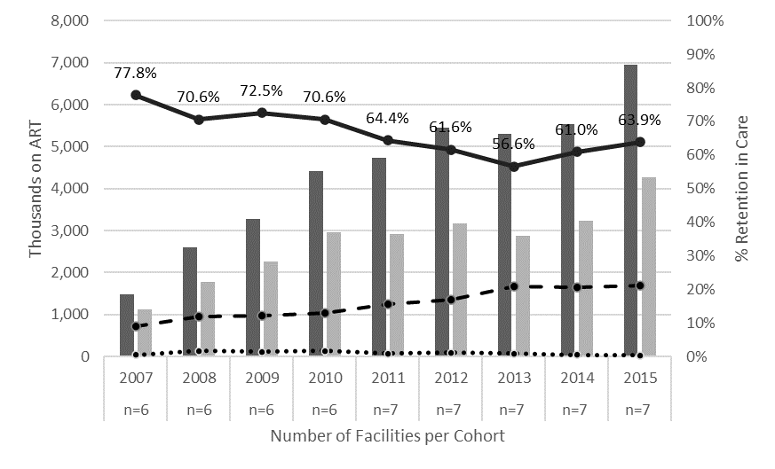
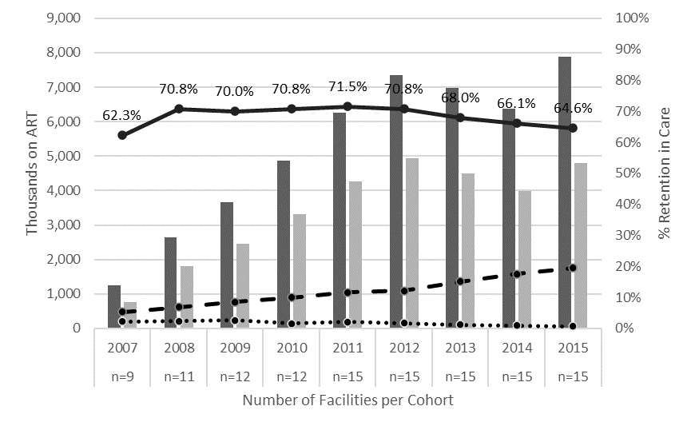

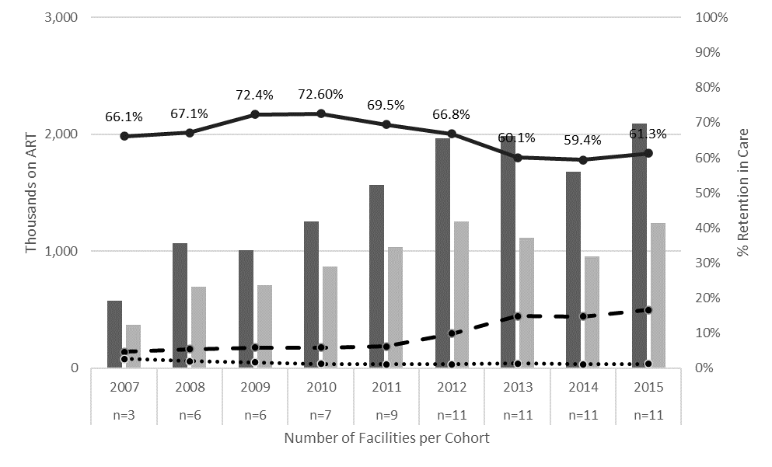
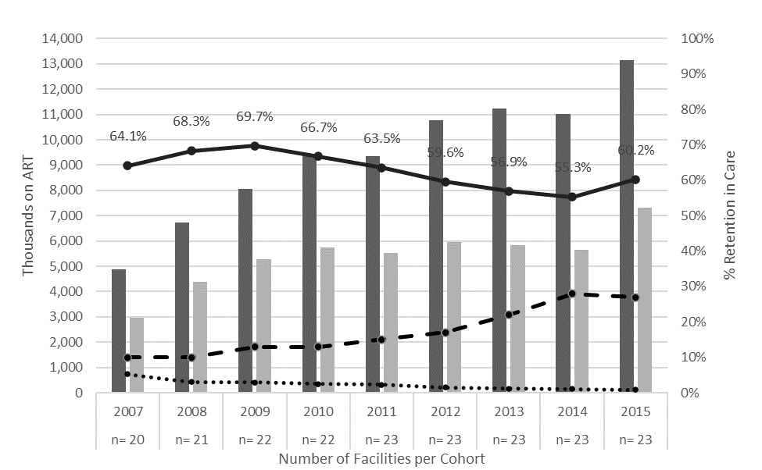

E e) Right to Care

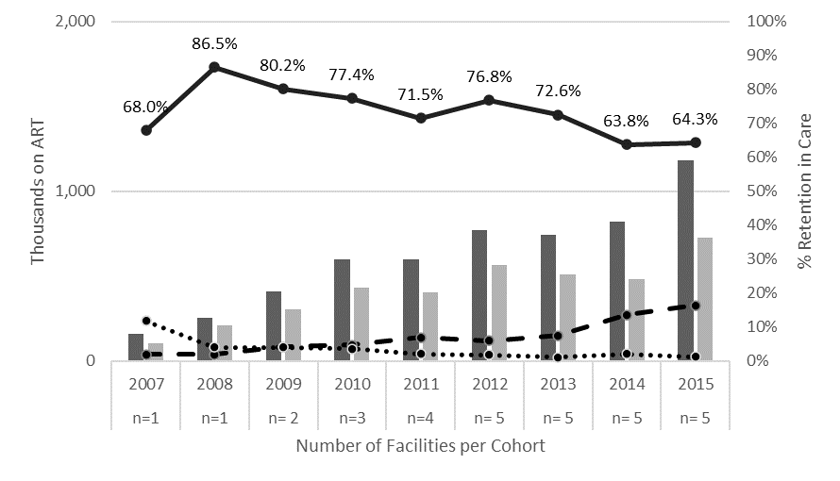

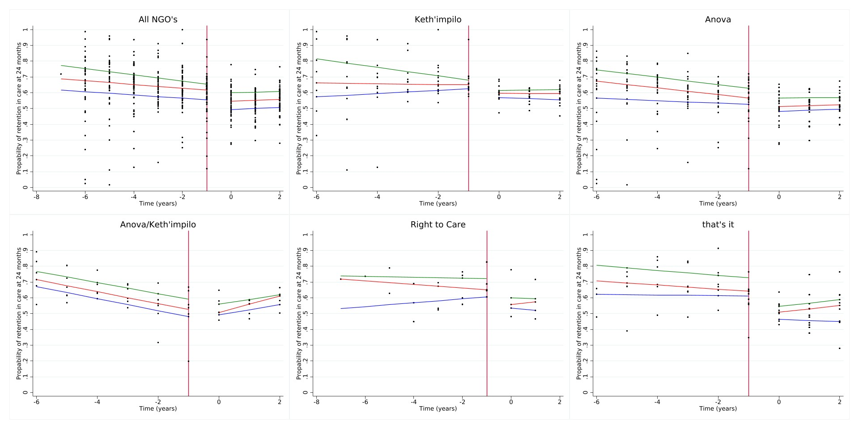
Supplemental Figure 2a-2f. Quantile regression estimates for 24-month retention stratified by NGO
NGO = non-governmental organization

